The San Juan Music Educators Association
awards this certificate of honor to
name of solo/ensemble
Of
Name of school
in the
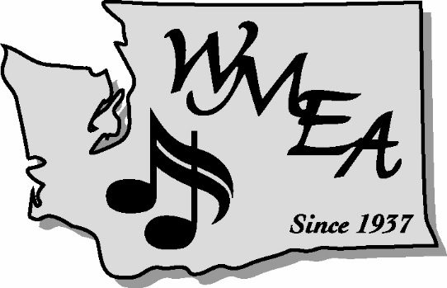
Junior Solo and Ensemble Contest held
February 6, 2016
Kulshan Middle School
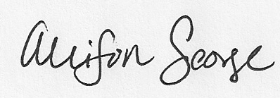
J.J. Cully
Contest Chairperson

